ACCESSING REMOTE WORKER TRAINING
VISION RESOURCE CENTER
Step 1: Use Portal Guard, SJECCD’s single sign-on platform https://sso.sjeccd.edu
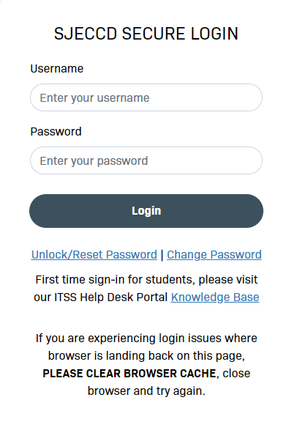
Step 2: Click on the California Community College Vision Resource Center – Prod tile
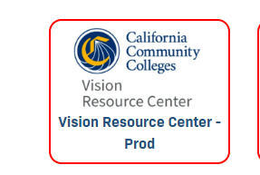
Step 3: Click on the California Community College Vision Resource Center – and you will see this CCC Vision Resource Center Webpage. Click on “Learn”
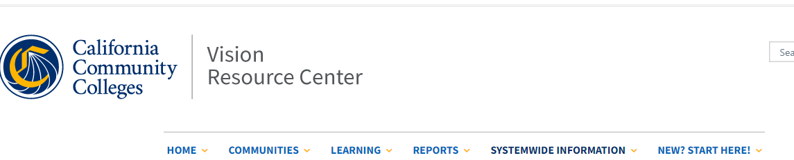

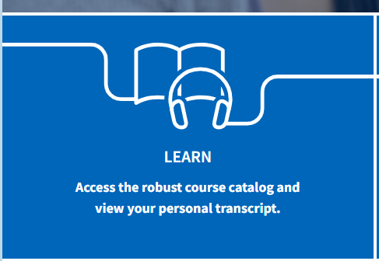
Step 4: You will routed to the page where you can search for topics. In the search bar type “Remote”
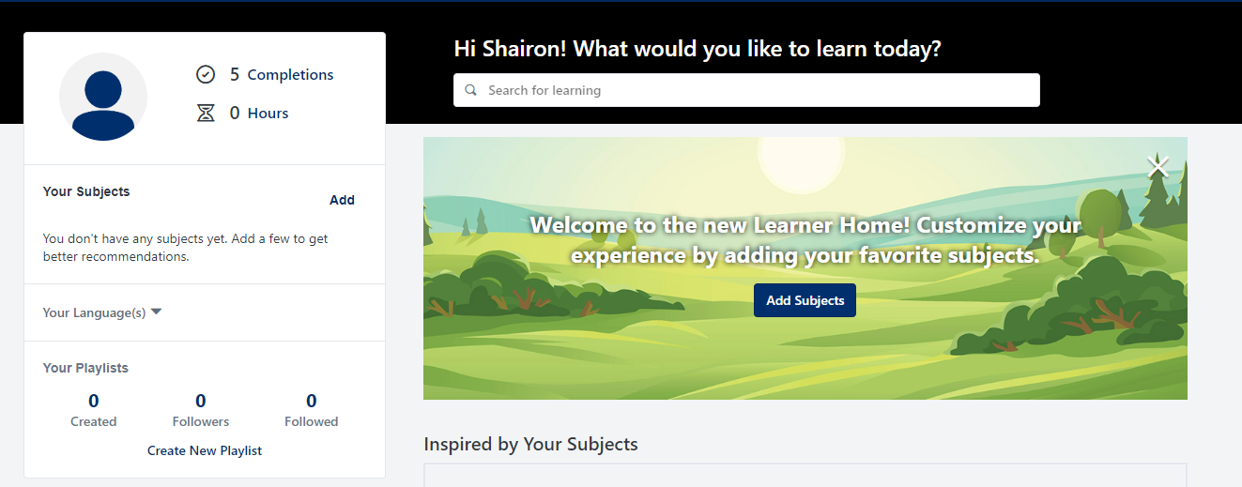

Step 5: You will then see a variety of training titles. Navigate or search for the training title assigned on the Training Sheet. You are welcome to take as many courses as you like.

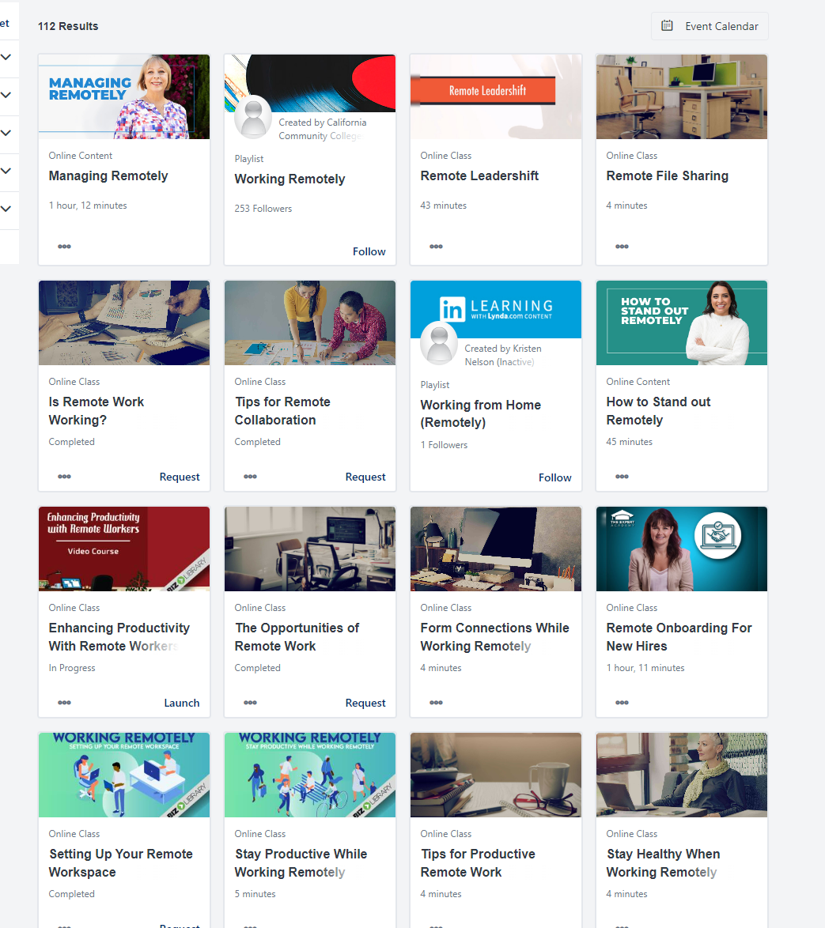
Step 6: After you have completed the training and taken the quiz. Save and exit. You can then get a copy of your transcript or certificate by navigating to “Learning” then “Transcripts”
